**Prodigy’s Tale**

**SEASON: 1**

**CHAPTER 2: “Venturing onto unfamiliar lands”**

As the council’s cadets were handed their first mission, they prepared their basic needs and were given a quick overview of the dimension they would be entering. When the cadets finished the preparation, they proceed to the portal platform. It was heavy guarded with humanoid robot combatants, carrying towering weapons and many menacing soldiers all over the place. The Cadets lined up till the Commander and other members of the council arrives, when the Commander and council members arrives, the Commander gives a fierce speech in how would the cadets should act kind. As the speech finish they stand and march to the portal.

It was already afternoon beyond the portal, and the sun was shining in the west. Concrete walls and buildings surround the cadets, but the concrete walls couldn’t hide the majestic gigantic tree in the east as the clouds fostering its branches and embracing the tree trunks, also the walls couldn’t filter the wind as it carries an ominous and eerie feeling from a desolated tree trunk peeking at the Forward base in the western walls, they waited until the Secretary of the Supreme Commander arrives and welcomes them to the foreign world then guide them to the Main HQ. While in the trucks the cadets keeps fidgeting, so the secretary looks where the cadets are gazing, he smirks, it was the “The desolated tree trunk”, so he gave the cadets a friendly pointer for surviving in this base; “Follow Order”.

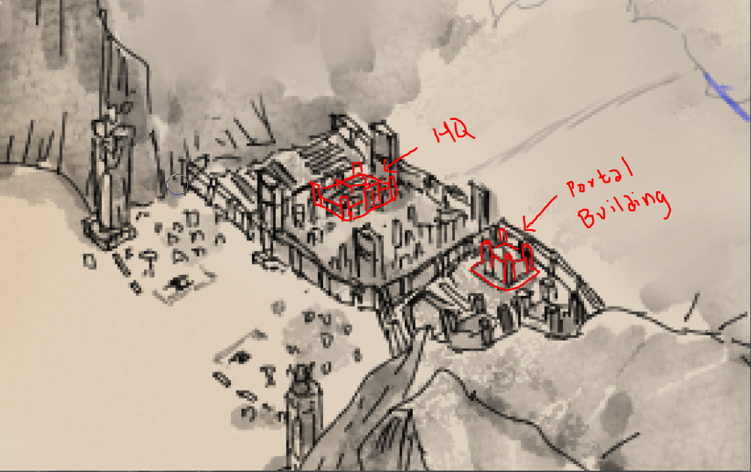

*Figure 1: Forward Base*

The Main HQ building located at the center of the forward base (see figure 1). As the cadets entered the HQ they’re lead to the hall. And instructed to wait. When the Commander-in-chief arrives at the hall they greet him with a salute. There should be a speech for welcoming the cadets but the time was not on their side as the alarms activated; the hoard strikes again and its not midnight yet the hoard starts to form and ready to attack the forward base, so the Commander-in-chief give them the first task and it was to **Participate in eradicating the hoard (we can make it a daily participation for the players need to eridicate monsters and halt them for advancing faster unless they are not given a task outside the forward base)(**, The other members of the Forward Base completely objecting the task and keep on telling that the cadets are for different mission but the Commander-in-chief heartily laughs and told them that “Nothings beats the of experiencing it first hand in the first day”, the platoon of cadets was divided to form a squads, Javier beingthe best cadet, he was given the role of a Squad Captain and lead a squad (it was to asses him).

As platoon of cadets approached the gate, numerous gun shots and explosions heard from the distance. They are given a briefing that what ever they saw in there keep head clear and just follow the order. When the gate finally opened, the trucks they’re riding went full speed out to the battleground, they shocked in how the monster from the manual looks totally monstrous than in the manual, towering bodies and massive wave of monsters. The Squad of Javier was located at the southern part of the battlefield where a massive influx of monster was located. The soldiers in here have a harden face of veterans compared to the sloppy cadets other than Javier almost every one including he’s squad was tense. Aim and shoot, reload and aim and shoot, the never ending repetitive process continues to repeat until the midnight approaches where the towering monsters finally make it move and marches forward to the base. **(Boss Fight, Mechanics: maybe save time only because gun powder is useless and the MC needs to create his weapon???)**

*Figure 2: Battle Grounds*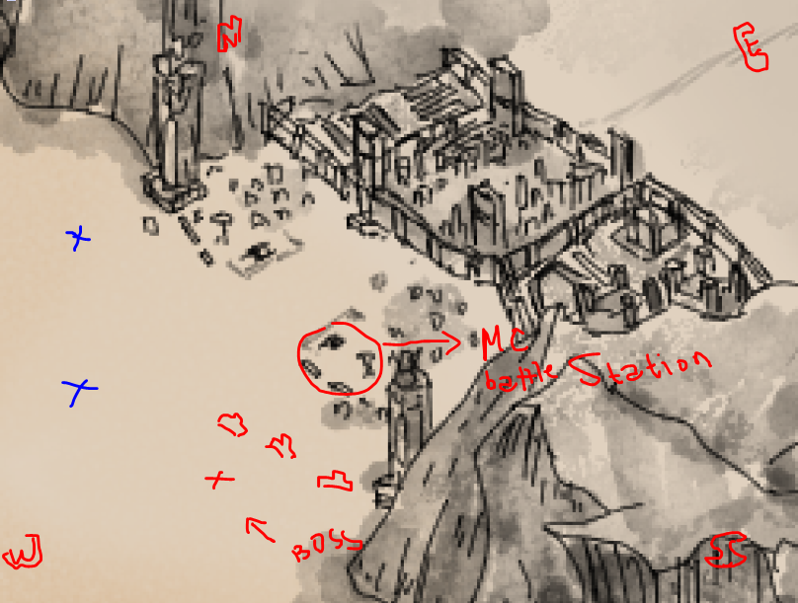

For the last 3 years of the Forward base it was always the same pattern, when the midnight comes and the moon hides behind the clouds, countless monster spawns and raging to go out of the desert and the forward base stop it as the *“Contract as i ettelen invaders”* (Contract with the foreign invaders) states that *“For you, the invaders to step on my sacred ground you must block the filth of the old desolated memories of the past”*  it was a totally one sided contract for the defeated First Expeditioners. But for the last 2 months before the 4th year the pattern changes and the monster wave comes in different time schedule and in additional gigantic monster was added and only heavy gun powdered weaponry of the base was the only way to destroy it. But as the time goes by this monstrosities started to get tough and almost can’t be destroyed, the forward base requested weapons and personnel to the committee and so the greedy committee members used this to apply their authority within the forward base, especially when they learned that there are unique materials, energies, and the natives of this world.

The gigantic monster in the south-western started to move, it was sizes of a Mammoth with black oozing goo keep on flowing out of its body; it was locked out by the might of heavy weapons and slowly chipped out its vitality. As the heated battle between the Forward Base and the monster are in a deadlock a sudden mishap of sending cadets was the key for the events and turned it into a chaos. The western part where Javier was a cadet in another squad’s gun misfired and killed a heavy weapon soldier, it was all it takes for the smaller monster to pour in and the other heavy weapon have no choice but to change target. The Mammoth finally have the time to charge at the soldiers when Javier didn’t have a choice and takes his entrance to fully engage with the Mammoth, he annoys it by keep on firing on its eyes till the agro shifted unto him. **(Now should we kill the Mammoth or only annoy it, I think that this worth to be discussed with the team for game mechanics)**

When the first light of the sun appears, the battlefield transforms into a sea of cries as the monstrosities melt into dust and blend inside the desert, signalling the end of the battle, dozens of trucks poured out of the base to collect dead comrades and tend the injured. Javier was held as a hero within the battlefield for engaging such monstrosity and coming back alive (well technically he’s not the only one who did that, but coming out alive and well was a different story). Upon coming back to the Forward Base to take a rest Javier was called out to the Main HQ.

Within the meeting room the Forward Base personnel and the Committee agents having a fierce argument because of the mishap happened with in the battle. The accused Commander-in-chief was silently listening to the two side bickering each other, that’s when Javier walks into the meeting room. Silence descends to the meeting room and all eyes are on Javier. The Commander-in-Chief laughs and says, "Why won't we let this newbie determine my fate?" everyone on both sides was taken aback by the ridiculousness. Javier looked around the room, perplexed, and was about to inquire what was going on, when the Secretary of Commander-in-Chief's stated that it would be addressed later and decided for the present problem. The secretary ask Javier, “Do you know **\*insert name*?”,** and Javier answer “He’s my uncle, sir”, “Good, do you know what you did out there?”, Javier thinks solemnly before answering, “Doing what seems to be the right, sir!”, the secretary smirks at the MC and “Look everyone we have a hero here!” and continue to smirks at Javier, Javier was slightly irritated and started to argue when the secretary interrupted him by declaring to the others that they had finally found the right candidate for the special assignment.

**END OF CHAPTER 2**